BRUCETOWN BANNER
FEBRUARY |2024

“connecting people to the love and grace of Jesus,” “amazing grace, unending love”

PASTOR’S CORNER
“BUT THOSE WHO HOPE IN THE LORD WILL RENEW THEIR STRENGTH. THEY WILL SOAR ON WINGS LIKE EAGELS; THEY WILL RUN AND NOT GROW WEARY; THEY WILL WALK AND NOT BE FAINT.” ISAIAH 40:31
The challenge is for us to “wait” and to be “renewed”. Too often we want to soar on ahead. We find ourselves discouraged and at times just tired and without hope when perhaps we have failed to “wait”. We put our hope in our circumstances, our dreams, our desires, our friends, or family members rather than in the Lord and we grow tired and weary. BUT- scripture gives us such wonderful ‘but’ messages “but God so loved” …and so we are assured, “but” those who wait, who hope in the Lord will (not might; will) have their strength renewed. Renewed enough to soar…to run and not grow weary, to walk and not be faint.
During this season of folks coming and folks going, or our church ministries growing and changing, during this time of perhaps evolving into what God is calling us to be “in” and “as” the Body of Christ it is time to claim the “But” in God’s promise that we will be renewed. As a pastor it has been a time of temptation to grow weary. It can be a time to just “pause” or to rush ahead when God is calling to wait and be strengthened, I (we) do not go alone. During this season, I have fallen on my knees before my God, and have bowed my heart time and time again, I have been filled with the rekindling of the excitement of serving God. My focus God redirects - to be on my God. Too easily it can turn to be channeled on the “other” on people and the temptation to “people please” to be liked, accepted, or have less “bumps in the road”. Perhaps you can relate from where your own view may be directed. May we wait and be renewed. God gives us strength for the bumps.
As I shared a few Sundays ago (again), the enemy does not come at us in bright red warning colors. It is far too easily to yield to temptation or become derailed in our work for God’s Kingsom due to the tactics of the deceiver – “father of lies”. But God is my hope. God is our hope. Wait on the Lord who remains the Alpha and the Omega, the Creator, Lover of my soul, God of all my days. God is God and when the enemy sought to destroy… God “But God” who loves us so much -God sent God’s only son, Jesus to save us.
May we always remember, see, act & believe on the “But God”.
God will renew our strength and we will not even walk in our work for the Kingdom we will soar!
May today this be our prayer….
Blessings, Pastor Susan
Eagle’s Wings
Song by Hillsong Worship
Here I am waiting
Abide in me I pray
Here I am longing
For You
Hide me in Your love
Bring me to my knees
May I know Jesus
More and more
Come live in me
All my life
Take over
Come breathe in me
And I will rise
On eagle's wings
Source: LyricFind
Songwriters: Reuben Timothy Morgan
Eagle’s Wings lyrics © Capitol CMG Publishing

LAY SERVANTS AND ANYONE INTERESTED!

The Shenandoah River District Lay Servant Ministries Committee is holding a training day Saturday, March 16 at Strasburg United Methodist Church.

We will offer Basic Course, Leading Worship, and United Methodist Heritage classes. Lunch will be provided.

Online registration will open soon.

More details will be available on the District website and in the February District newsletter.

LAY LEADER’S CORNER
Thank you! With February being a month, we think of hearts and love and expressing our gratitude, I would like to express my appreciation for my church family. I am thankful for each one of you.

A faith community – I enjoy being surrounded by other believers in Christ. I have a need to be filled afresh each week by the Holy Spirit and to be restored by encounters with other believers.

Me a lay leader – I never pictured myself in this role. I lack the confidence to get in front of a congregation and speak, but each of you is gracious in your encouragement and generous to overlook my stumbling. From Acts 20:28– ‘So guard yourselves and God’s people. Feed and shepherd God’s flock–His church purchased with His own blood–over which the Holy Spirit has appointed you as leaders.’ This is us! Christians are called to build one another up. This came to me this past week in a new light– Patrick Mahomes is going to be in the Super Bowl- again! Nobody wants that. I could find ways not to like him, but then I came across a post from another Christian acknowledging her appreciation of Patrick Mahomes as a Christian. A Christian who struggles with the task of playing a grueling sport, overcoming the many obstacles of the game, the other players, the coaches, the fans, and the not-so-much-fans. It was then I thought, he has a Christian heart. Why am I tearing his successes down just because I don’t want the Chiefs in the Bowl again this year. But more importantly– God called him to a Christian faith just as God calls you and me. We are called to love our neighbor as ourselves. What’s more important?

Overcoming self-doubt– Each year instead of concentrating on a new year resolution, I try to think of a word to focus on throughout the year. It helps me to grow in my faith. This year I’ve chosen a phrase- ‘come alongside’. Just as I thank God for each of you and the ways in which I learn of your faith by your witnessing that helps me grow in my faith, I want to do that for another or others. I have three wonderful friends who many years ago we came together for a weekly Bible study. Along the way we learned a lot about God’s Word. We shared a lot of personal challenges together. We held each other accountable and encouraged each other to grow in a personal relationship with God. I dearly love each of those ladies and the impact they have had in my life and my faith walk. I want to embrace God’s call to make disciples of men. Would you join me this year in 1) pray for me that I will seek God’s will to have the confidence to ‘come alongside’ another in their faith walk, and 2) seek a new way in which you can use your spiritual gift to aid in the work of His kingdom!?!

Lisa Tri, Lay Leader

An invitation to Adult Sunday School Class
The Bible is the Christian's "handbook for life." Within its pages we learn about what is right and what is wrong by learning what God and Jesus did. We cannot completely learn what the acronym “WWJD” means (what would Jesus do?) if we do not first learn ‘what did Jesus do’ and ‘what did Jesus say.’ We have often been told that it is better to know Jesus than to just know about Jesus. That is certainly true, but wouldn’t it be better if we knew both; to know Jesus and to know about Jesus so we could know him even better? The Message Bible translation in Ephesians 5:1-2 puts it this way: “Watch what God does, and then you do it, like children who learn proper behavior from their parents. Mostly what God does is love you. Keep company with him and learn about a life of love. Observe how Christ loved us. His love was not cautious but extravagant. He did not love to get something from us but to give everything of himself to us. Love like that”
We are reminded that faithful discipleship is not a one-time goal, it is a lifelong journey. While on this journey, we are encouraged to become lifelong learners and influencers. Involvement and participation in Sunday school, Christian education, small group study, or whatever name we give it, is a wonderful way to be faithfully discipling in this lifelong journey.
…and now, here is the Adult Sunday School invitation for you:
Sunday School is not just for children. …we are never too old to learn, and all adults are invited to join the Crusader’s Sunday School Class…this Crusader’s class has been meeting for over 50 years... .and are still learning. Church records indicate adult Sunday School classes were part of the beginnings of Brucetown Church as early as the 1880’s). We meet every Sunday from 9:45AM to 10:35AM and are presently using the Bible-in-Life Comprehensive Bible Study to explore a very informal, open-to-all learning levels, scriptural-based Bible learning experience. Currently, our study theme is FAITH: February = Faith commitment. March = Nurturing faith. April = Range of faith. May = Standing in faith.
You are invited. Come and join the Adult Sunday School Class:
….all adults, young adult through older adult, are invited to join in Brucetown UMC’s adult Crusader’s Sunday School hour. This hour spent together is a wonderful time to continue learning the story of God's relationship with the masterpiece of his creation – You.
Thank You, Hope to see you there, The Crusaders Sunday School Class. Forrest Smith

Lenten Study
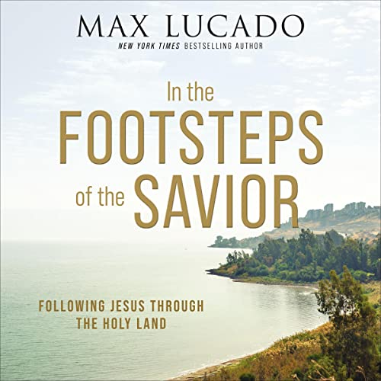
Lenten Study: In the Footsteps of the Savior (Max Lucado). We will meet on Mondays at 6 pm (5:45 a light dinner will be offered) at Emmanuel UMC. Please join in and invite your friends. There are six books available and you may purchase your own copy online at www.amazon.com or Christianbookdistributors.com or another venue. Please let Pastor Susan know if you would like one of the six available books.

Lenten Devotions
We will gather at 10 am to share in a time of devotions and prayer at Brucetown UMC. Please stop in to participate on all or any of the weeks during the Lenten season.

Lent Study and Devotion Dates
Mondays
Feb. 19, 26 and March 4, 11, 18, 25 @ 6 p.m. @ EUMC. There will be a lite dinner provided.

Lenten Study Devotionals and Prayer Time
Mondays Feb. 19, 26 and March 4, 11, 18, 25 @ 10 a.m. at BUMC.

Brucetown News and Events
Prayer and Conversation – 2024 brings new dates to meet and gather for prayer and conversation at Applebees. We plan to gather at 2 p.m. on Wednesdays. All are invited.

Dates: February 28th, March 27th, April 24th, May 22nd
Bright Futures – Bright Futures is scheduled for the following dates: 2/21; 3/20; 4/17; and 5/15
Pastor Susan in Leadership Cohort – Pastor Susan will be participating in the VAUMC Clergy/Leadership Cohort. This cohort will meet both in-person and via Zoom from January through November 2024. Pastor Susan will be in Richmond attending the first session Monday, January 8th thru January 11th.

Cohort Date:

Feb. 21st – Zoom
March 14th – Zoom
May 13-16 – Richmond
July 17th – Zoom
August 5 – 8 – Richmond
September 16-19 – Richmon
October 16th – Zoom
November 18 – 21 - Richmond

Parent’s Night Out – Parent’s Night Out is scheduled for 5 p.m. to 8 p.m. for the following nights:

4/12; 9/27; 12/13

As we move forward with PNO, we are hoping to be able to split the children into two groups – younger children up to age 9 and older children 10 and above. We will begin each session with both groups with dinner, then break out into our individual groups. Each group will then have a short bible lesson before moving on to a craft and/or play time.
EUMC Community Meal – Free meal available to all on the 4th Monday of the month from 4 p.m. to 5:30 p.m. Upcoming dates are 2/26 and 3/25.
Brucetown Methodist Men Breakfast – The Methodist Men at Brucetown United Methodist Church invite the men of the men of the church to enjoy breakfast on them. This is a terrific opportunity for fellowship and a great way to kick off the New Year.

The event is scheduled for 2/3 at 9 .m. at Cracker Barrel.
Chicken Dinner to Support the National Break Cancer Foundation – We will hold our next dinner to support the NBCF on 10/19 at 4 p.m.. More details to follow.
Sharing of Our Bounty – The Free Giveaway will take place on 9/7 at 9 a.m. As we move closer to the date an email will go out requesting the donation of items and when to drop them off.
Ice Cream Social – Back by popular demand. We will have an ice cream social at Brucetown open to one and all. The event will be scheduled for 7/18 at 6 p.m. Stay tuned for more details.
Spaghetti Dinner and Basket Raffle – The dinner and basket raffle will benefit the retrofitting of the kitchen, i.e., pots, pans, knives, etc. The event will be hosted on 2/24 at 4 p.m. Be on the lookout for more information.

Senior Luncheon
EUMC Community Meal
Community Meal – The EUMC Free Community Meal will be held on the 4th Monday of each month, 4:30 - 6:00 p.m.
You are warmly welcome to join EUMC and have a very delicious dish that will be served in the basement of the Church building.

Senior Luncheon is scheduled for 2/6 at 11:45. A lunch of chili and cornbread will be provided. Attendees will have their choice of selecting from a variety of chilis being prepared by the members of our congregation. Once lunch has concluded, attendees will play a few rousing games of Bingo – always a big hit.
If you would like to donate prizes for bingo, please see Melissa.
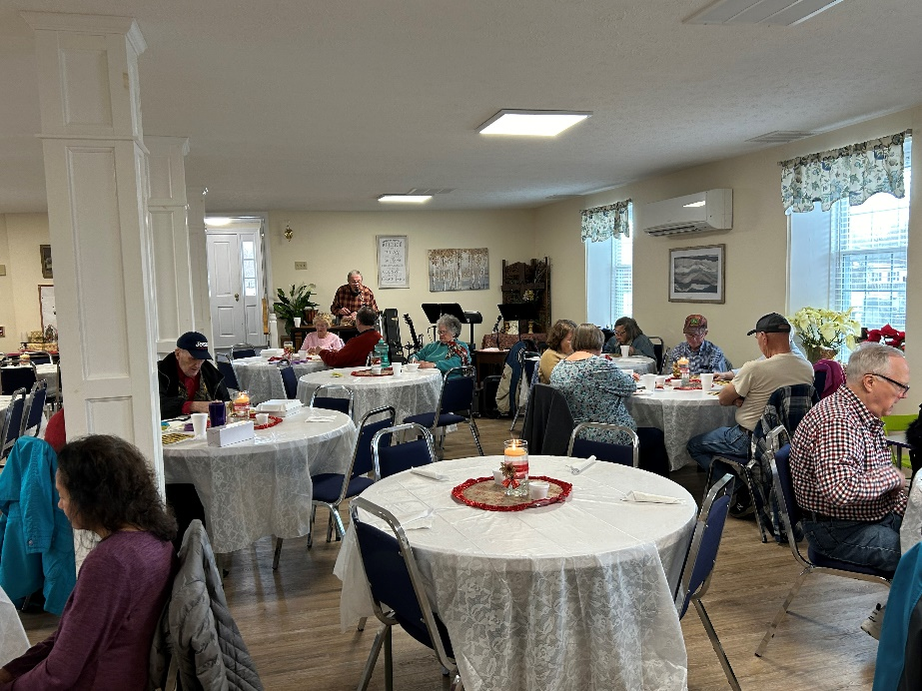
Senior Luncheon - Bingo with Brent

“Grace is when God gives us good things that we don’t deserve. Mercy is when He spares us from bad things we deserve. Blessings are when He is generous with both. Truly, we can never run out of reasons to thank Him. God is Good All The Time!”

When Will You Become a Disciple of Christ?
A pastor transformed himself into a homeless person and went to the church that he was to be introduced as the head pastor at that morning. He walked around his soon to be church for 30 minutes while it was filling with people for service. Only 3 people said hello to him, most looked the other way. He asked people for change to buy food because he was hungry. No one gave him anything.
He went into the sanctuary to sit down in the front of the church and was told by the ushers that he would need to get up and go sit in the back of the church.
He said hello to people as they walked in but was greeted with cold stares and dirty looks from people looking down on him and judging him. He sat in the back of the church and listened to the church announcements for the week.
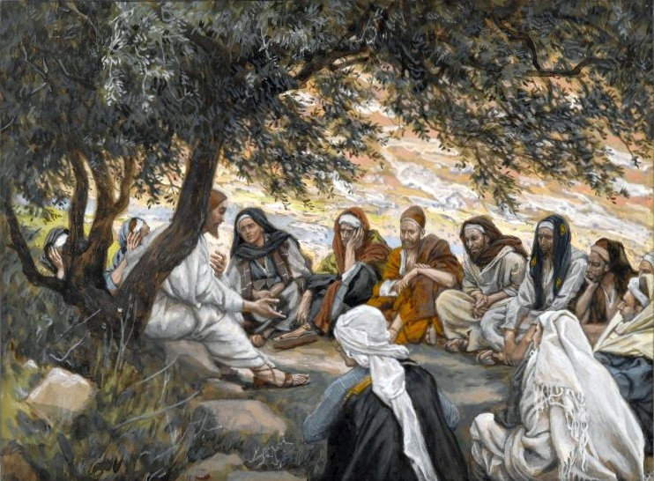
He listened as new visitors were welcomed into the church that morning but no one acknowledged that he was new. He watched people around him continue to look his way with stares that said you are not welcome here.
This Photo by Unknown Author is licensed under CC BY-NC-ND
Then the elders of the church went to the podium to make the announcement. They said they were excited to introduce the new pastor of the church to the congregation. "We would like to introduce you to our new Pastor." The congregation stood up and looked around clapping with joy and anticipation. The homeless man sitting in the back stood up and started walking down the aisle. That's when all the clapping stopped and the church was silent. With all eyes on him....he walked up the altar and reached for the microphone. He stood there for a moment and then recited so elegantly, a verse from the bible....
“Always pray to have eyes to see the best in people, A heart that forgives the worst, A mind that forgets the bad, And a soul that never loses faith in God.” Excerpted from Old Photo Archive
[Cite your source here.]
“Then the King will say to those on his right, ‘Come, you who are blessed by my Father; take your inheritance, the kingdom prepared for you since the creation of the world. For I was hungry and you gave me something to eat, I was thirsty and you gave me something to drink, I was a stranger and you invited me in, I needed clothes and you clothed me, I was sick and you looked after me, I was in prison and you came to visit me.’ “Then the righteous will answer him, ‘Lord, when did we see you hungry and feed you, or thirsty and give you something to drink? When did we see you with a stranger and invite you in, or needing clothes and clothe you? When did we see you sick or in prison and go to visit you?’ “The King will reply, ‘Truly I tell you, whatever you did for the least of my brothers and sisters, you did for me.’
After he recited this, he introduced himself as their new pastor and told the congregation what he had experienced that morning. Many began to cry and bow their heads in shame. "Today I see a gathering of people here but I do not see a church of Jesus. The world has enough people that look the other way. What the world needs is disciples of Jesus that can follow this teachings and live as he did. When will YOU decide to become disciples?

Financial Updates
The following is the past month’s offerings and attendance at services, to include donations for special projects and/or fundraisers that may have been held.
Week | Adults | Children | Offering | Hope Fund
1/28/2024 | 42 | 9 | $1,335
1/21/2024 | 31 | 6 | $717
1/14/2024 | 32 | 3 | $3,710 | $55
1/7/2024 |  |  |  | NO SERVICE - SNOW

QuickBooks
The Financial Team of Brucetown UMC will be moving toward utilizing QuickBooks accounting software for financial transparency. This will allow the team to move from the current system of manual accounting to a more streamlined and automated system of accounting that will improve overall efficiency and reporting. If you have any questions on this new process, please see either Mike Fraser or Deb Bernabeu.

United Women of Faith
Church Family,
My, how fast the days are flying by. The holidays are over and January has passed. We will soon be in the Lenten Season.
I would like to recap a few of the 2023 UWF activities. Our busiest months are from September until December of each year. Last year proved not to be an exception. In early November, we prepared dinner for the first WATTS meal of the cold season with members of the church serving.
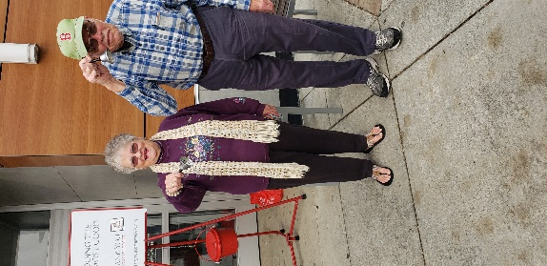
We scheduled and organized BUMC members to ring the bell for Salvation Army. On the Friday before Thanksgiving, our group rang from 10 a.m. until 6 p.m. We were blessed with a beautiful, sunny and warm November day. One bell ringer even wore sandals! Thank you so much to all those who volunteered.
We sponsored a Bright Futures family for Christmas. Lisa did the shopping and delivered the gifts to Bright Futures. Thank you, Lisa.
Our plastic recycling program is still going strong! Thank you to everyone who is collecting and bringing their pla
stic to the church. Besides Wayne and Norberto who collect at their worksites, the Clear Brook, Stephenson and Berryville post offices are collecting for us. Seniors who come to the monthly Senior Luncheon are bringing plastic. At the time of this writing, we have submitted over 700 pounds!
Our ladies and guests enjoyed a Christmas Luncheon in the Fellowship Hall
on December 16th instead of our regular program and business meeting. Thank you, Pastor Susan, for arranging this social event.
Due to bad weather the January meeting was cancelled.
Our next regular meeting will be February 17. At the March meeting, we will have Viki Barb as guest speaker. She will be sharing information about the Prison Ministry Program.

Morning Devotions

Have you ever read something that just speaks to you? I’m sure you have. Recently, I read the following devotion for Matthew 28:20 – Jesus, undeterred, went right ahead and gave his charge: “God authorized and commanded me to commission you: Go out and train everyone you meet, far and near, in this way of life, marking them by baptism in the threefold name: Father, Son, and Holy Spirit. Then instruct them in the practice of all I have commanded you. I’ll be with you as you do this, day after day after day, right up to the end of the age.”

“…and surely I am with you always, to the very end of age.”

I am always with you. What a sweet reminder that God is forever by our side. He is with us at the beginning of our lives and will be with us at the end when he calls us home. Don’t you take comfort from know that you are never truly alone?

“Let my love enfold you in the radiance of My Glory. Sit still in the Light of My presence and receive my Peace.”

Do you remember the first time you fell in love. That feeling of butterflies in your stomach, or you felt slightly nauseous. Your pulse raced and your palms started to sweat. When you were with that person you may have felt a sense of calm and peace like you never felt before. They felt like they completed you.

Isn’t that what the love of God should be like? A first-time love that goes on til the end of time. A love that is everlasting, unquestioning, excepts you for the good and the bad? His love is unconditional.

God brings us a Peace that we all need in our lives. Like water quenching our thirst, the ever-whelming Peace God provides quenches our soul.

Don’t you want to have a love like that?

Brucetown UMC – Serving Our Community, Enjoying the Fellowship of One Another
Gathering for Fellowship, Devotion, Food, Music and Fun at the Brucetown Corner Café
Drop in any Thursday Evening 7 pm
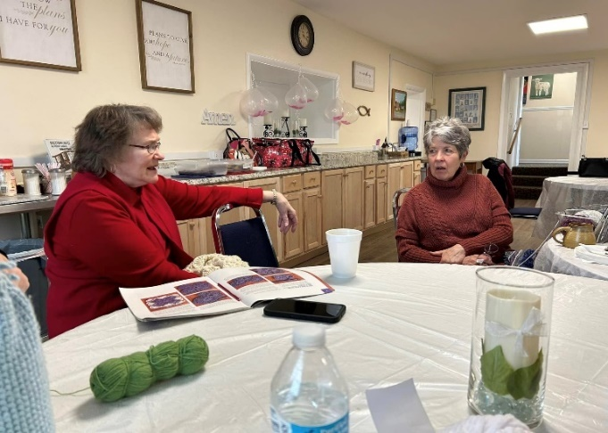
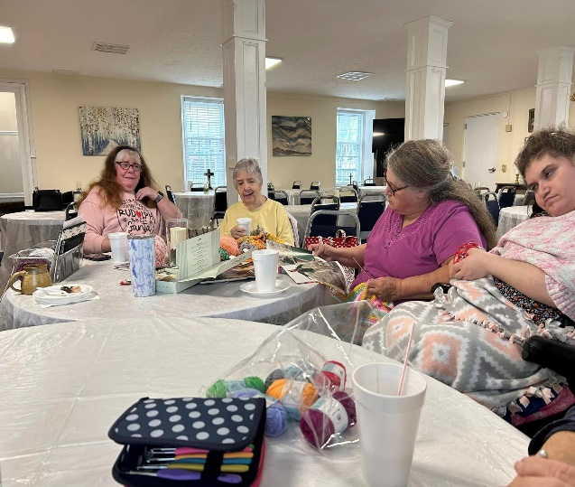
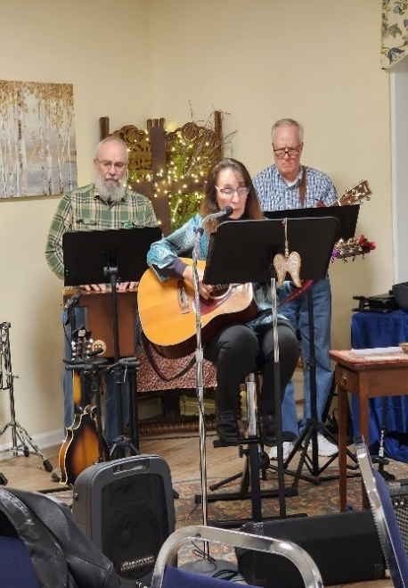
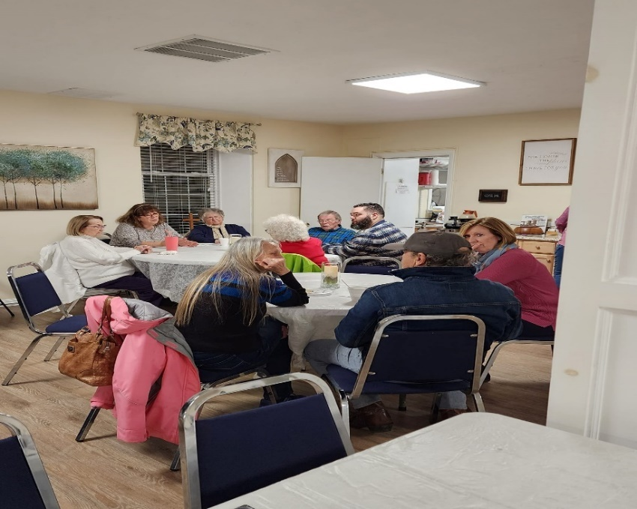
Crafty Corner and Conversation…. Monthly at Brucetown UMC. See Melissa Conaty for more information.
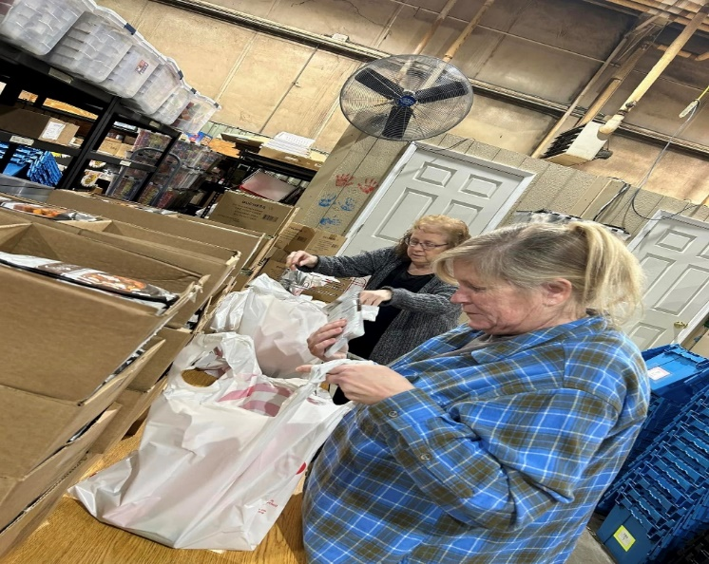
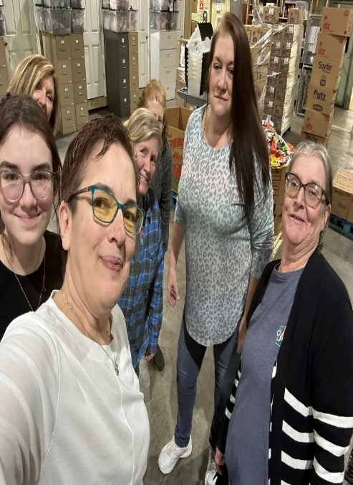

Packing the Backpack Food @ Bright Futures…Hands & Feet of Christ at Work!
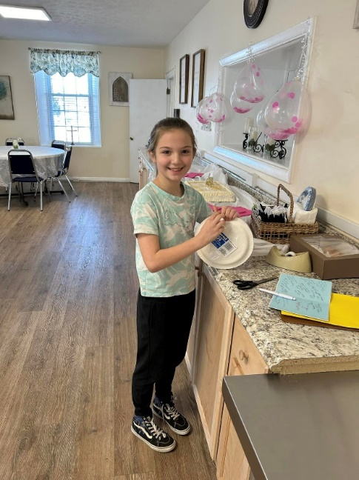
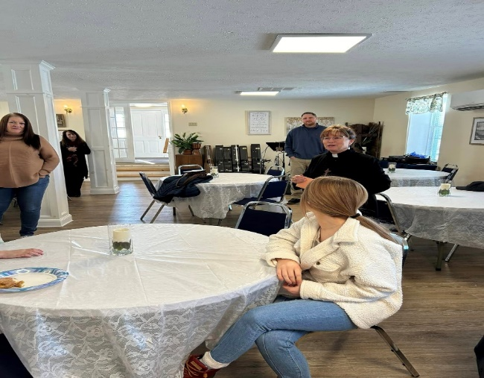

Birthday Surprise for Pastor Susan

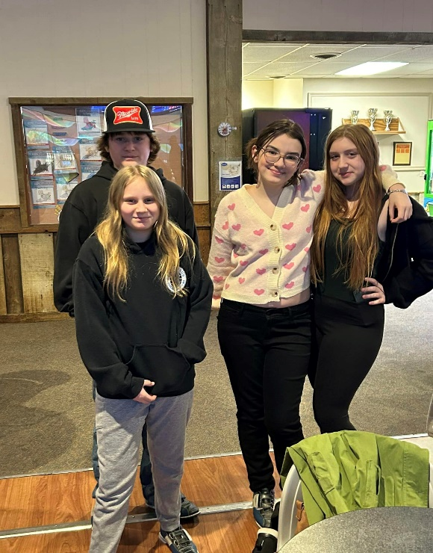
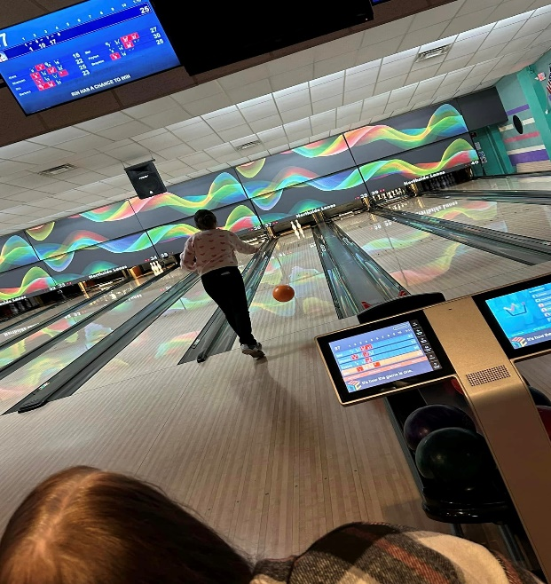

Youth Bowling

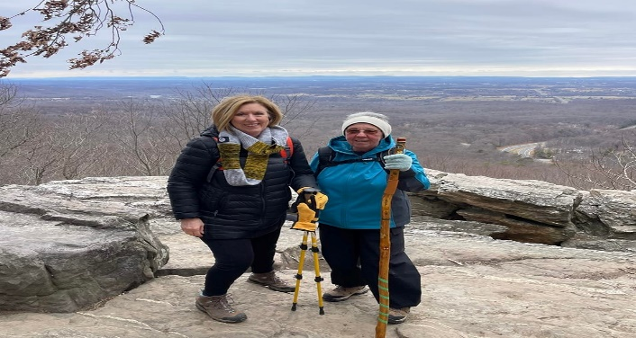

Friends Hiking

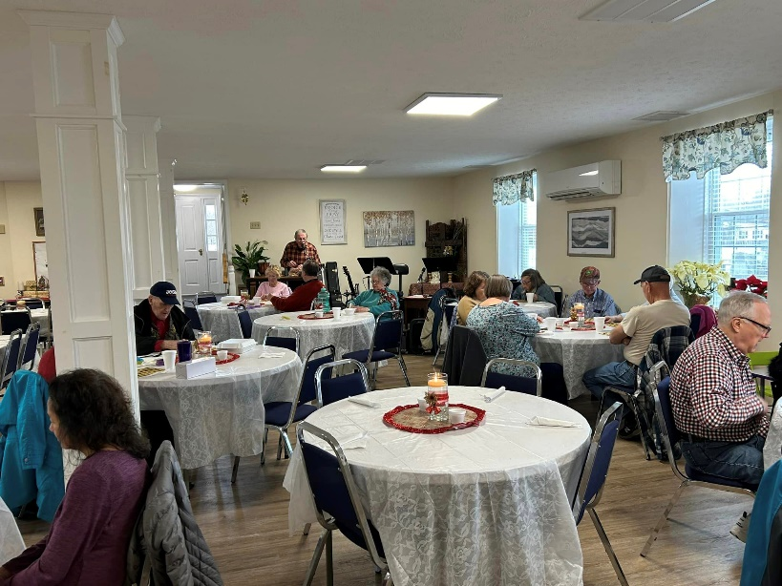

Senior Luncheon

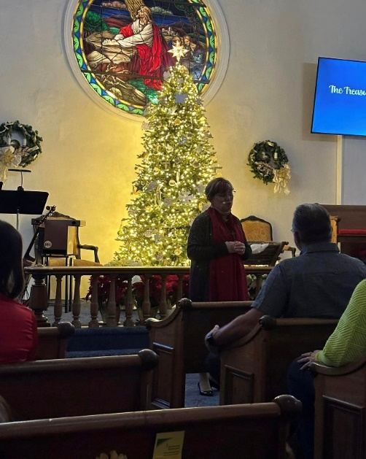
December Worship Celebrations
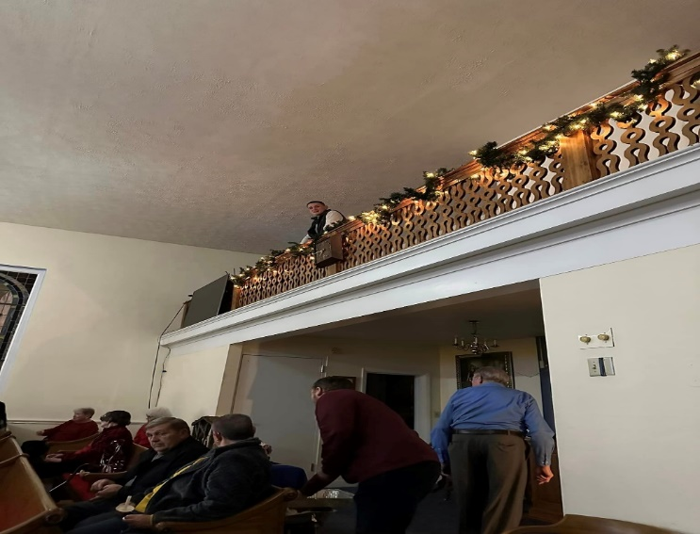

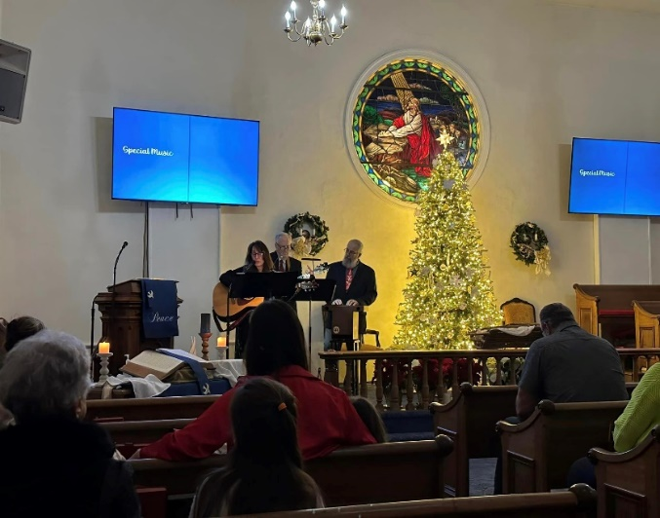
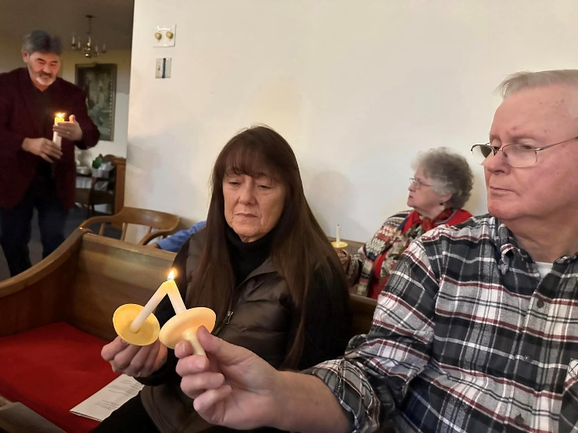
Candlelight Christmas Eve Service
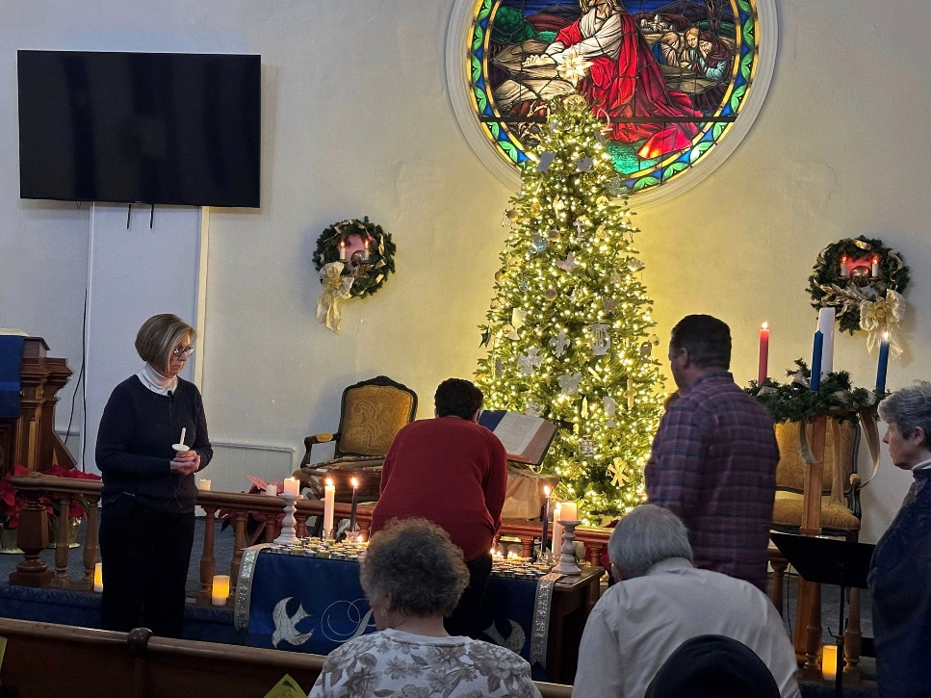

Blue Christmas Service

