2024
Feb
This Photo by Unknown Author is licensed under CC BY
Pastor’s Desk
2161 Brucetown Road
Clear Brook, VA 22624
540-667-5275
Brucetowncalendar2@gmail.com

‘
To share from Wesley’s Covenant Service … May we give ourselves to Christ, that we may belong to him. Christ has many services to be done. Some are easier and more honorable, others are more difficult and disgraceful. Some are suitable to our inclinations and interests; others are contrary to both. In some we may please Christ and lease ourselves. But then there are other works where we cannot please Christ except by denying ourselves. It is necessary, therefore, that we consider what it means to be a servant of Christ. (UMC BOW pg. 291)
We have walked together in ministry for several seasons as two congregations serving as the hands and feet of Christ in our community. Some steps have been easier and some more challenging to navigate, however the result has been spiritual growth and companionship with a deepening and wider sharing of our faith stories and our service. My prayer is for our work and ministry together to continue.

As we begin “again” it is a time to reflect on our direction for 2024 both as individuals and as the Body of Christ, as our two congregations being impactful for the Kingdom of God in our community.
This year may we commit ourselves more readily to Christ as his servants.

“connecting people to the love and grace of Jesus,”
“amazing grace, unending love”
Are you looking for some resolutions for the new year? What better place to look than the Bible Take a moment to read the following..

- 2 Timothy 2:23-24
- James 1-5
- Colossians 3:13
- 1 Corinthians 19:20
- Titus 2:7
- Joshua 1:9
- Ecclesiastes 4:9-11
- Matthews 25:34-40
2024 New Years Resolutions
Brucetown Banner
As we reflect individually upon our spiritual journey and our service there are those we are called too or provided opportunities to minister to one another that are more rewarding, pleasant, and fun and those that we shy away from or become hesitant to engage in doing. May we seek both this year.

First and foremost, let us seek Christ and the direction of God above our own selves and desires. May we become known as a faithful community of brothers and sisters sharing in the love and grace of God.

From Yearning to Know God’s Will by Danney E. Morris:
God wants everyone to know God’s will. God doesn’t withhold grace, play games, or tease us to test our faithfulness or our worthiness to be trusted with divine insight. I am
convinced that God is far more prone to human revelation than I am to divine encounter.

God’s will be that you and I, everyone, and our faith communities should discern and act upon Gods’ will.
Let us seek God’s will in 2024.

Blessings. In the Love & Grace of Christ Jesus, Pastor Susan
Prayer and Conversation
2024 brings new dates to meet and gather for prayer and conversation at Applebee’s. We will plan to gather at 2 p.m. All are invited to attend.

January 24
February 28
March 27
April 24
May 22

A Morning Prayer - Excerpted from “Jesus Digital” on Facebook.

“When you wake up say: Jesus I love you…When leaving the house say: Jesus come with me…When you feel like crying, say: Jesus hug me…When you feel happy say: Jesus I adore you…When you do something, say: Jesus help me…When you make a mistake, say: Jesus forgive me…When you go to sleep say: Thank you Jesus and cover me with your holy mantle.”

Home – “Everyone needs three homes…A family home, a church home, and a Heavenly home. And Jesus Christ is the key to all three.” Adrian Rogers

8 Things to Remember When Going Through a Tough Time
- Everything can – and will – change.
- You’ve overcome challenges before.
- It’s a learning experience.
- Not getting what you want can be a blessing.
- Allow yourself to have some fun.
- Being kind to yourself is the best medicine.
- Other people’s negativity isn’t worth worrying about.
- And there is always, always, always, something to be thankful for.

tten
Council Corner

Updates coming February 2024

From Henri Nouwen Society
Blessed to be a Blessing

It is remarkable how easy it is to bless others, to speak good things to and about them, to call forth their beauty and truth, when you yourself are in touch with your own blessedness. The blessed one always blesses. And people want to be blessed! This is so apparent wherever you go. No one is brought to life through curses, gossip, accusations, or blaming. There is so much taking place around us all the time. And it calls forth only darkness, destruction, and death. As the “blessed ones,” we can walk through this world and offer blessings. It doesn’t require much effort. It flows naturally from our hearts. When we hear within ourselves the voice calling us by name and blessing us, the darkness no longer distracts us. The voice that calls us the Beloved will give us words to bless others and reveal to them that they are no less blessed than we.

Church Family

How Can You Help?

With the new year upon us, there are many ways for each of us to service our church. If you find yourself called to service, please take a moment to sign up for one of the many opportunities listed below. Sign-up sheets will be posted on the bulletin board starting 1/3/2024. Melissa will compile a main list and reach out to you to arrange final coordination of dates/times. Thank you in advance for your help.
- Greeter for Upstairs in the Sanctuary (month obligation)
- Acolytes
- Children’s Time Message
- Ushers for the Offering
- Offering Counters (monthly obligation)
- Hospitality Table Following Service
- Providing Assistance to Children’s Ministry Assistant (during service)
- Safety & Security (place “green men” out and check doors for unlocking and locking)
- Scripture Reading

Happy New Years! We have had a remarkably busy Advent season this year. We have had Parent’s Night Out, Senior Luncheon, Apple Butter, Yard Party, Chicken Dinner to support breast cancer, Children’s Christmas Program, and the Adult Christmas Program, to name just a few of the many events that have taken place throughout the year. I hope you enjoy the pictures below.

A huge thank you to everyone who helped make the many events that were hosted both at Brucetown and Emmanuel the outstanding events that they were.

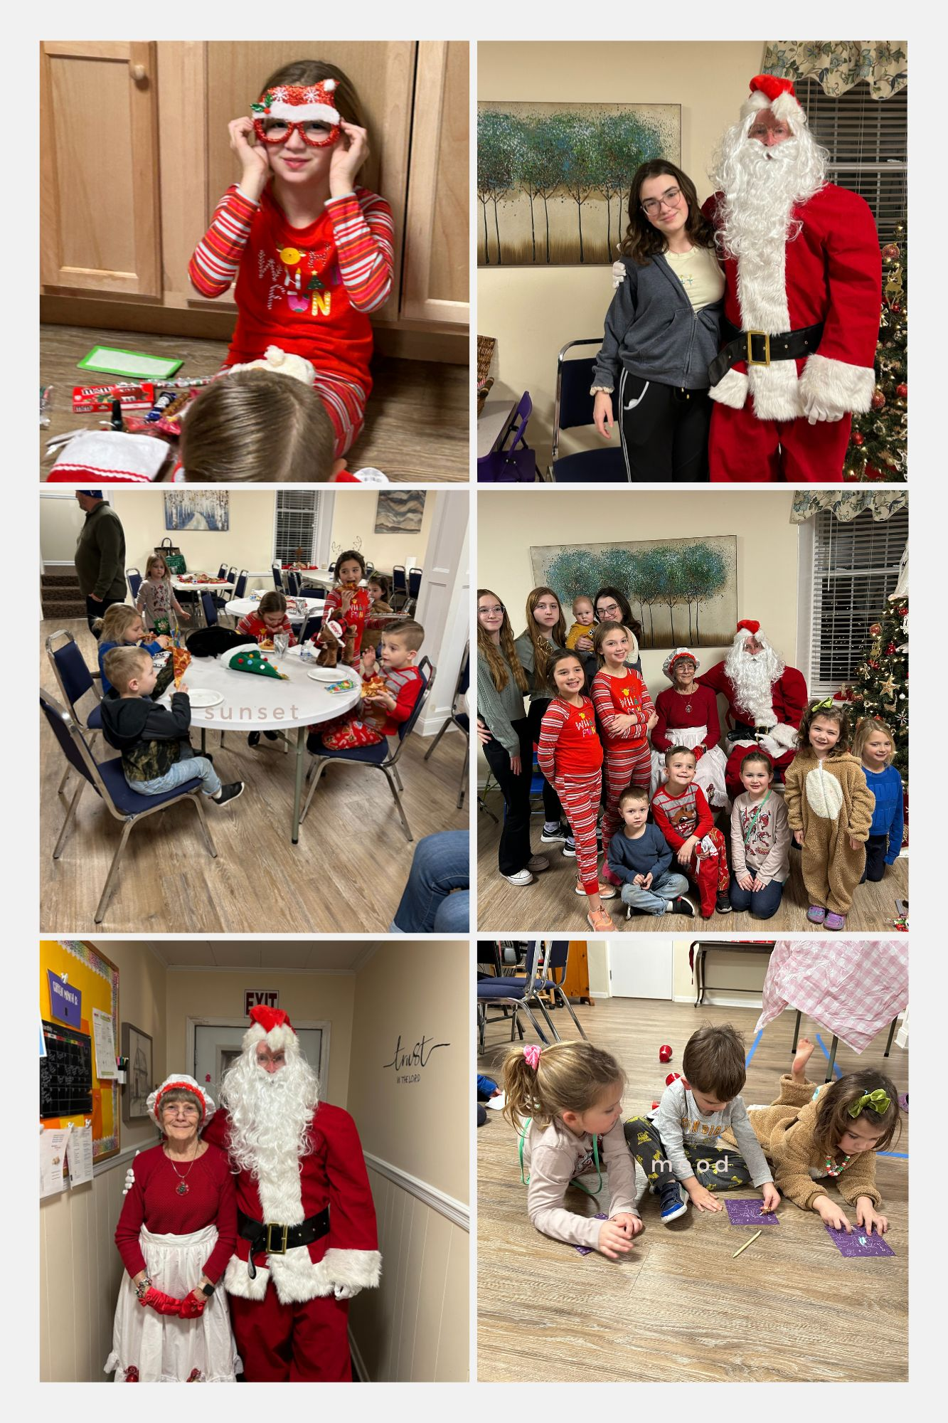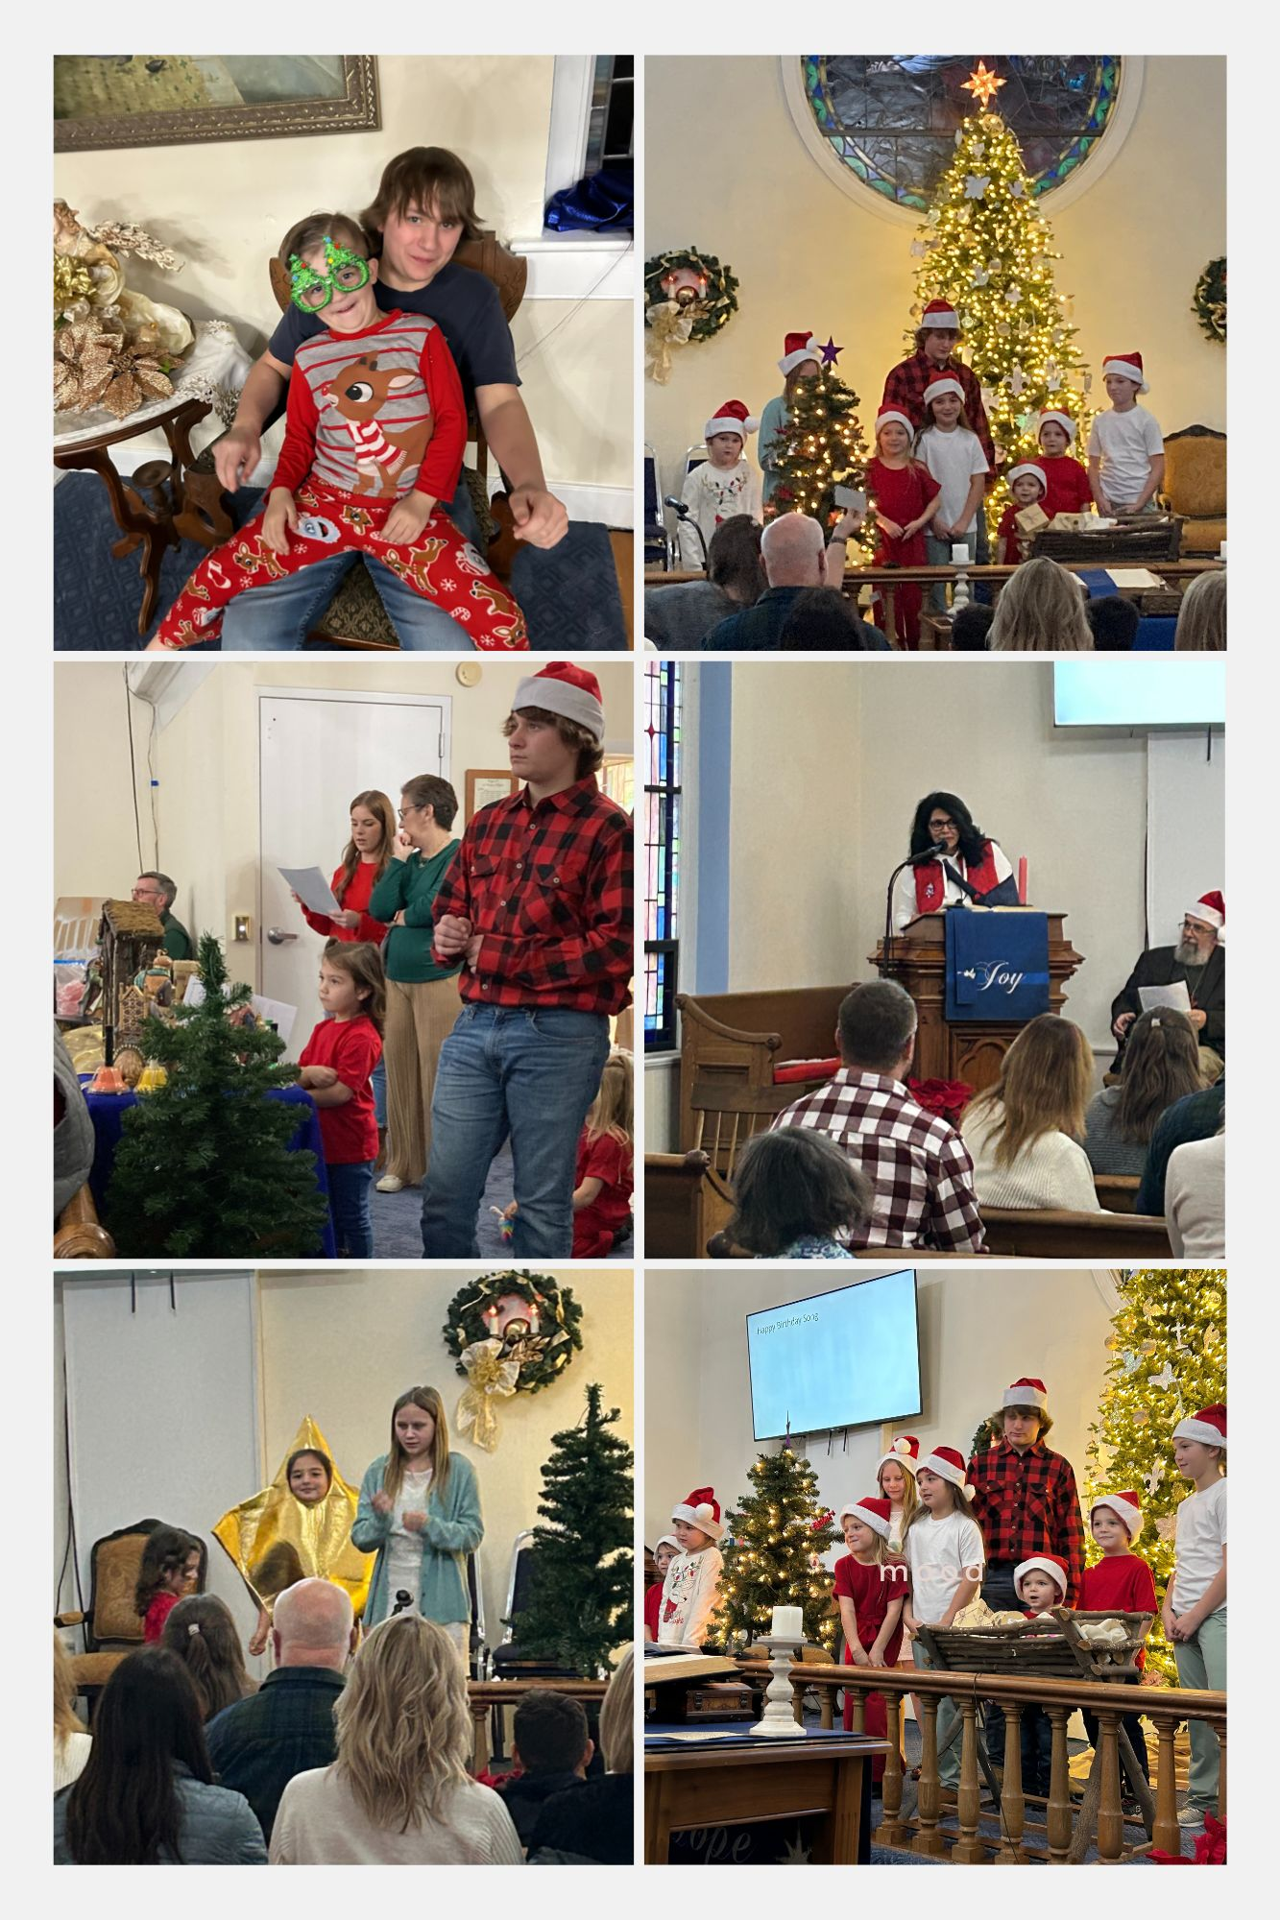
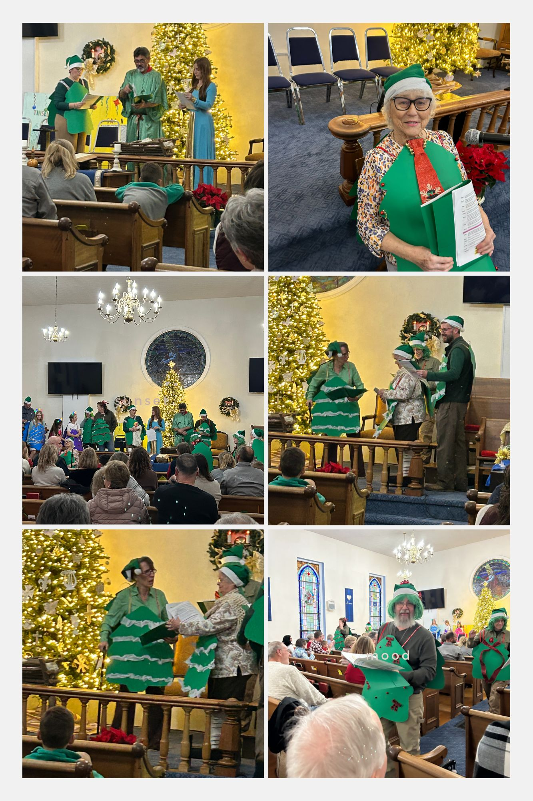
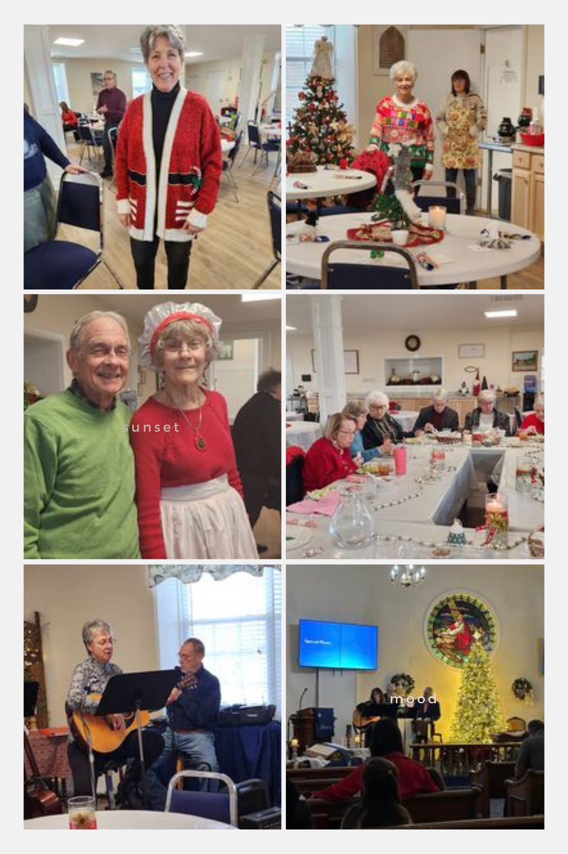
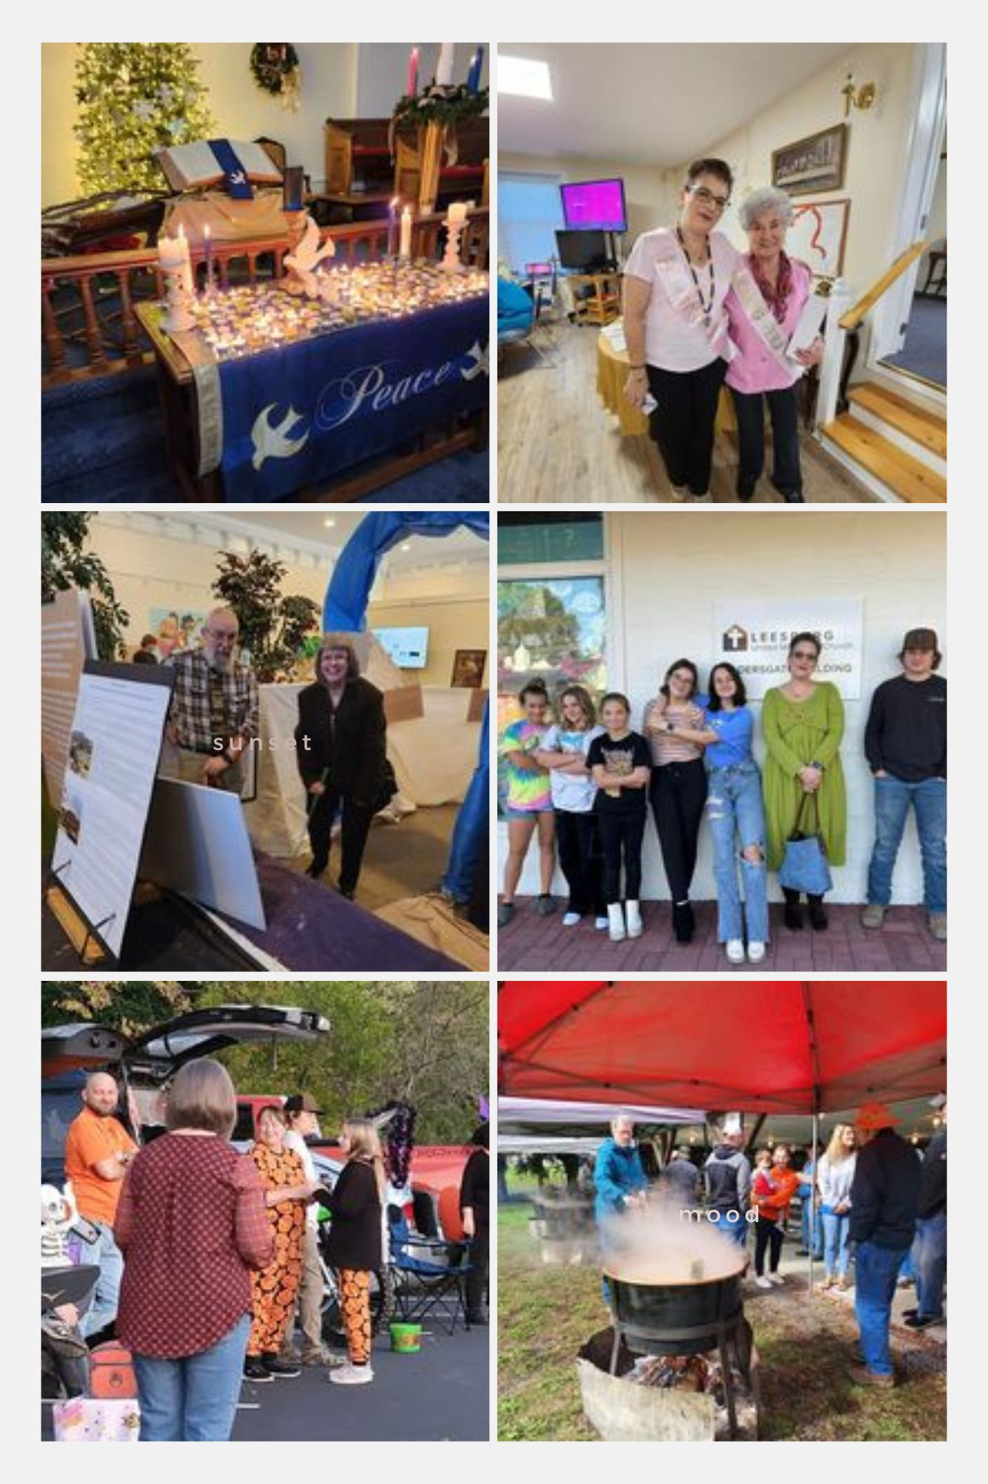
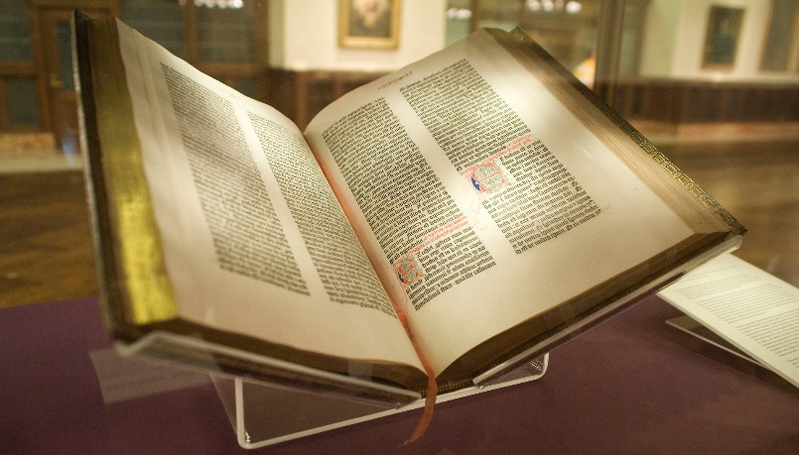
If you have gone on the EMMAUS walk and are interested in participating in a reunion, please let Melissa know (brucetowncalendar2@gmail.com). We are working to schedule a reunion soon for the pilgrims of BUMC and EUMC.
EMMAUS
January/ February Readings
Jan 7 Genesis 1:1-5; Psalm 29;
Acts 19:1-7; Mark 1:4-11
Jan 14 1 Samuel 3:1-10;
Psalm 139: 1-6, 13-18; 1
Corinthians 6: 12-20;
John 1: 43-51
Jan 21 Jonah 3: 1-5, 10;
Psalm 62: 5-12;
1 Corinthians 7: 29-31;
Mark 1: 14-20
Jan 28 Deuteronomy 18: 15-20;
Psalm 111;
1 Corinthians 8: 1-13;
Mark 1: 21-28

Feb. 4 Isaiah 40: 21-31
Psalm 147: 1-11
Mark 1: 29-39

Feb. 11: Transfiguration Sunday Kings 2: 1-12
Psalm 50: 1-6
Corinthians 4: 3-6
Mark 9: 2-9

Feb. 14: Ash Wednesday Joel 2: 1-2; 12-17
Psalm 51: 1-17
Matthew 6: 1-6, 16-21

Feb. 18: 1st Sunday in Lent Genesis 9: 8-17
Psalm 25: 1-10
Mark 1: 9-15

Feb. 25: 2nd Sunday in Lent Genesis 17: 1-7, 15-16
Psalm 22: 23-31
Mark 9: 2-9
This Photo by Unknown Author is licensed under CC BY-SA
Finding An Agent That’s Right For You

